**Summer Internship Report**

Internship Role: Data Analyst Intern  
Organization: JPCB Bank, Jalgaon  
Project: Cross-Selling Analysis Using MySQL & Power BI

Guide: Sagar Desai  
Duration: June 2025

**Project Overview**

As a Data Analyst Intern at JPCB Bank Jalgaon, I worked on a cross-selling analysis project using a self-created dummy dataset with 50 records per table, modeled using MySQL Workbench. After designing the schema and populating the data, I exported the tables as CSV files and uploaded them into Power BI for analysis.

The objective was to uncover cross-selling opportunities using customer behavior, transactions, branch performance, and service usage insights—helping the bank increase product adoption and revenue.

**Dataset Details**

* Created using **MySQL Workbench**
* **15 tables** with approx. 50 rows each
* Dummy dataset designed based on typical banking entities:
  + Customers, Products, Transactions, Branches, Insurance, Loans, Channel Usage, etc.

**Cross-Selling Analyses Implementation**

1**. Customer Product Penetration & Cross-Sell Matrix**

Identify segments with low product penetration (e.g., Loans, Insurance) to target for cross-selling.

* Tables Used: Customers, Customer_Product, Products
* Power Query Steps:
  + Merge Customer_Product with Products to fetch product_type
  + Filter where product_status = 'Active'
  + Create customer segment column:
    - High-Value: income > 8,00,000
    - Mid-Value: class = 'Class B'
    - Low-Value: All others
* DAX Measure:
* ProductCount = COUNTROWS('Customer_Product_Joined')
* Visual: Matrix
  + Rows: Customer Segment
  + Columns: Product Type
  + Slicer: Customer City

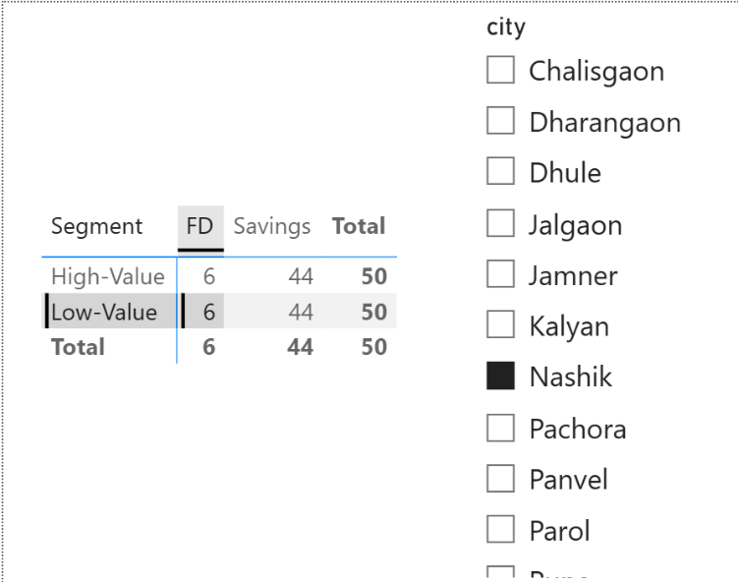

Customer Segmentation - Nashik :

* Nashik has equal numbers of High-Value and Low-Value customers.
* Fixed Deposits (FD): 6 each in both segments.
* Savings accounts are 44 in each segment, totaling 50 accounts.

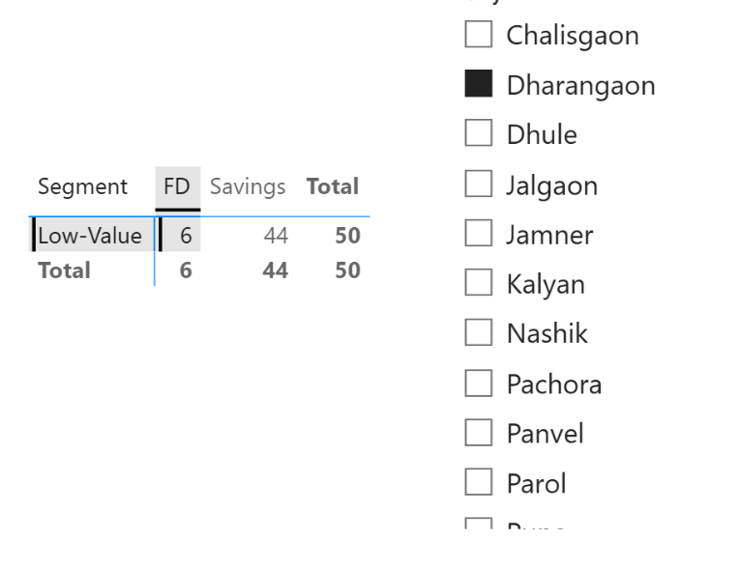

Customer Segmentation - Dharangaon :

* All customers in Dharangaon fall into the Low-Value segment.
* Same FD and savings account count: 6 FDs and 44 savings accounts.
* Insight: Focus campaigns where ProductCount is low for high-potential customers.

**Life Events-Based Offers**

Target customers at key life moments (e.g., marriage, loan inquiries) with relevant cross-sell products like health insurance or joint accounts.

* Tables Used:

Merge 2 (merged view of Customers + Customer_Visits), insurance policies

* Power Query Steps:
* Load Customers, Customer_Visits, and insurance policies.
* Merge Customers with Customer_Visits on customer_id.
* Merge resulting table (Merge 2) with insurance policies using Left Join on customer_id.
* Keep relevant columns: marital_status, visit_date, purpose, policy_type, status.
* DAX Calculated Column:

LifeEventOpportunity =

IF (

OR (

SELECTEDVALUE ( 'Merge 2'[marital_status] ) = "Married"

&&

CALCULATE (

COUNTROWS ( 'insurance policies' ),

FILTER (

'insurance policies',

'insurance policies'[customer_id] = SELECTEDVALUE ( 'Merge 2'[customer_id] )

&& 'insurance policies'[status] = "Active"

&& 'insurance policies'[policy_type] = "Health"

)

) = 0,

SELECTEDVALUE ( 'Merge 2'[purpose] ) IN { "Loan Query", "Account Opening" }

),

"Recommend Product",

"No Recommendation"

)

* Visuals Used:
* Chart Type: Clustered Column Chart
  + X-Axis: visit_date or purpose
  + Y-Axis: Count of customer_id or visit_id
  + Legend (optional): LifeEventOpportunity

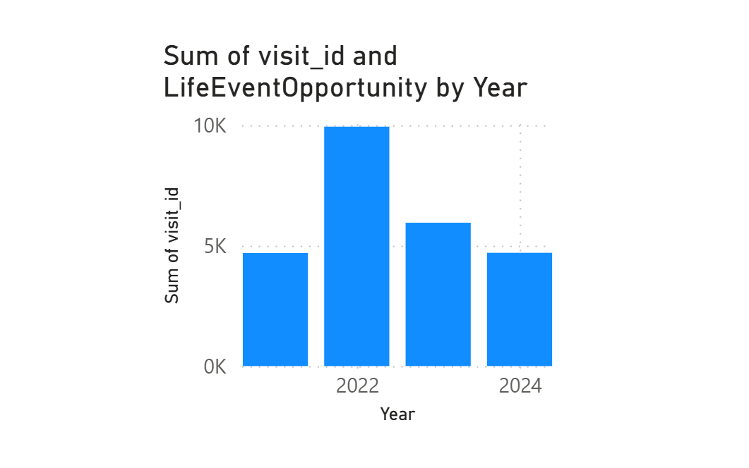

Explanation:  
This chart shows the sum of visits associated with life events like marriage or account/loan inquiries. The peak in 2022 indicates a higher number of relevant customer visits that year—ideal for launching contextual cross-sell campaigns.

* Insight:
* Identify and recommend cross-sell products for:
* Married customers with no active health insurance.
* Customers visiting for "Loan Query" or "Account Opening".

This ensures timely, relevant offers that increase conversion rates and deepen customer relationships.

3**. Loan Cross-Sell Score Dashboard**

Identify customers eligible for loans based on financial behavior.

* Tables Used: Customers, Customer_Product, Loan_Details, Transactions
* Power Query:
  + Group transactions to compute total amount per customer
  + Join with customers & active product holders
* DAX:

LoanEligible = IF( ISBLANK(CALCULATE(COUNTROWS('Loan_Details'), 'Loan_Details'[loan_status] = "Active")) &&

(SUM('Customer_Product'[balance]) > 800000 || SUM('Transactions'[amount]) > 500000),

1,

0

)

* Visuals:
  + Card: Eligible count
  + Slicer: Occupation

This visual displays customer counts across income levels in Class A. Most customers fall in the mid to high income brackets, making them strong candidates for loans, investments, or premium services.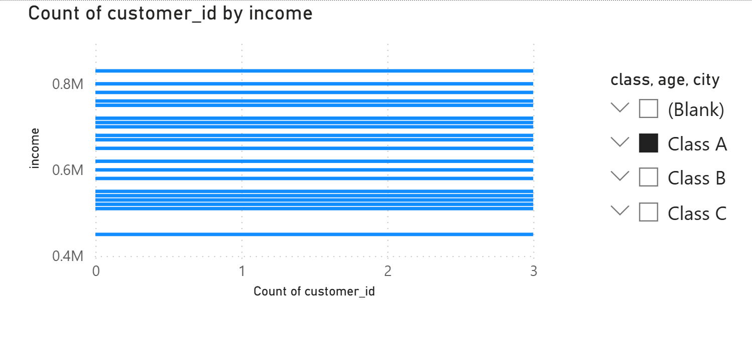

Customers in Class B have moderate income. This group can be targeted for basic cross-sell offers such as insurance or recurring deposits depending on their financial stability.A blue and white bar graph

The chart shows that MobileApp and NetBanking are the most used channels, especially by Class B users. This is a clear indication to promote digital products like e-FDs and SIPs through mobile and online platforms.

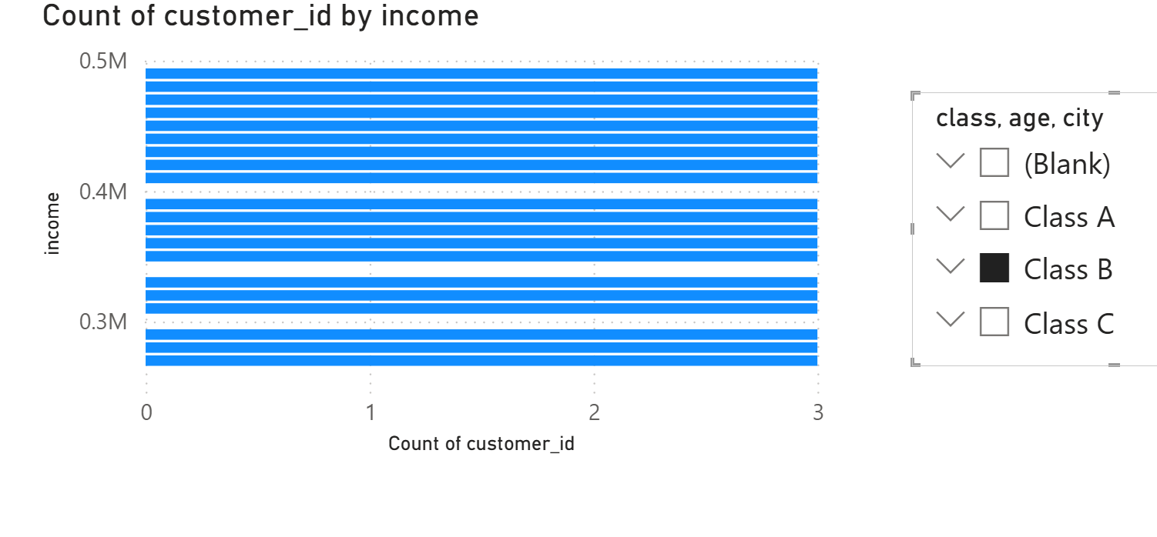

* Action: Export eligible customer list for loan campaigns.

4**. Insurance Gap Funnel**

Identify loan holders without insurance for targeted offers.

* Tables Used: Loan_Details, Insurance_Policies, Customers
* Power Query:
  + Left join loan data with insurance data
  + Filter active loans only
* DAX:

LoanCustomers = COUNTROWS('LoanWithInsuranceCheck')

LoanWithInsurance = CALCULATE(

COUNTROWS('LoanWithInsuranceCheck'),

'LoanWithInsuranceCheck'[insurance_status] = "Active"

)

LoanWithoutInsurance = [LoanCustomers] - [LoanWithInsurance]

* Visual: Funnel chart

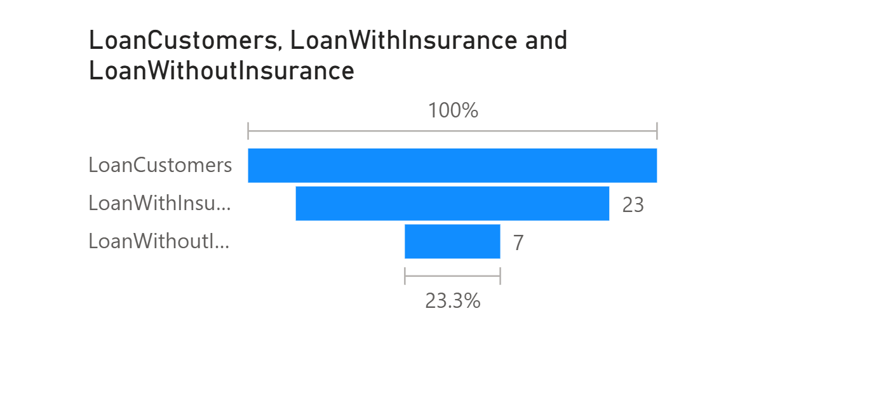

Explanation:  
Out of 30 loan customers, only 23 have insurance, leaving 7 (23.3%) without coverage. These uncovered customers should be targeted for credit life or health insurance upsell.

* Insight: Identify loan customers who lack insurance coverage.

5. Branch Cross-Sell Column Chart

Analyze branch-wise average product holding to prioritize regions.

* Tables Used: Branch, Customer_Product, Customers
* Power Query:
  + Group by branch, count products and customers
* DAX:

AvgProductsPerCustomer = DIVIDE(

COUNTROWS('Customer_Product_Joined'),

CALCULATE(DISTINCTCOUNT('Customer_Product_Joined'[customer_id]))

)

* Visual: Column Chart
* Axis: Branch.city or Branch.name
* Value: AvgProductsPerCustomer

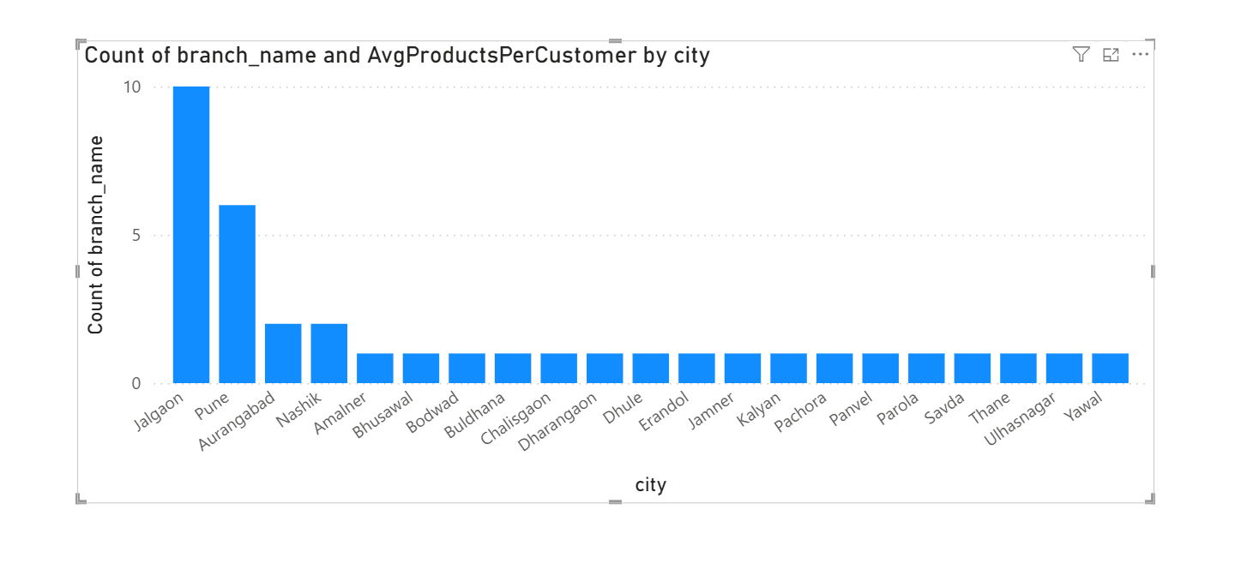

Branch Count by City (Chart 1):

* Jalgaon has the highest number of branches (10), followed by Pune (6).
* Most other cities have 1–2 branches each.
* This shows a concentration of branches in a few cities.
* Action: Launch campaigns in low-performing branches.

6. **Dormant to Active Campaign Analysis**

Re-engage customers with dormant products (e.g., FDs, Lockers).

* Tables Used: Customer_Product, Customers, Products
* Power Query:
  + Filter product_status = 'Dormant'
* DAX:

DormantCustomers = CALCULATE(

COUNTROWS('Customer_Product_Dormant'),

'Customer_Product_Dormant'[product_status] = "Dormant"

)

* Visual: Donut Chart
  + Category: product_status
  + Slicer: Product Type

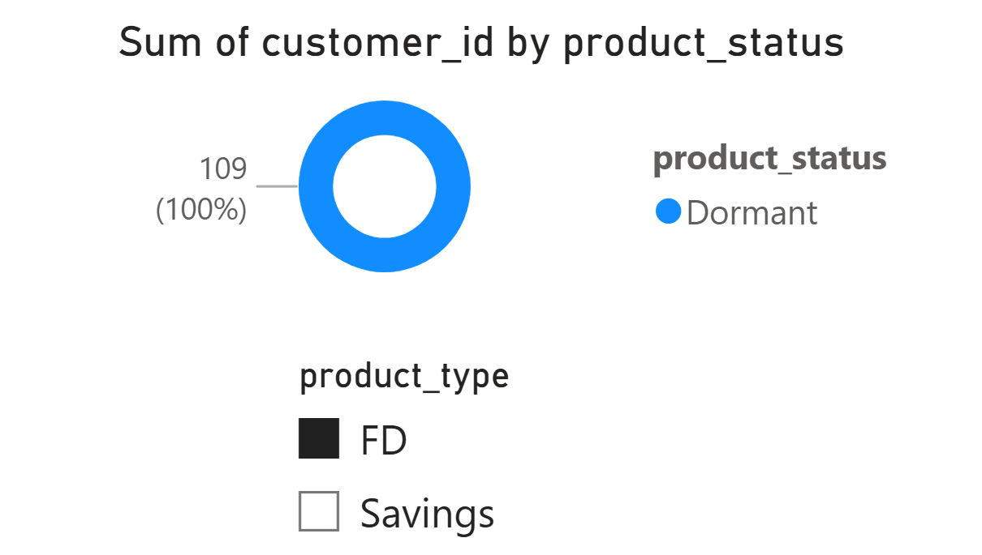

Explanation:  
A donut chart showing 100% of 109 customers having dormant FD accounts. This highlights a large group that can be re-engaged with fixed deposit renewal campaigns or special rate offers.

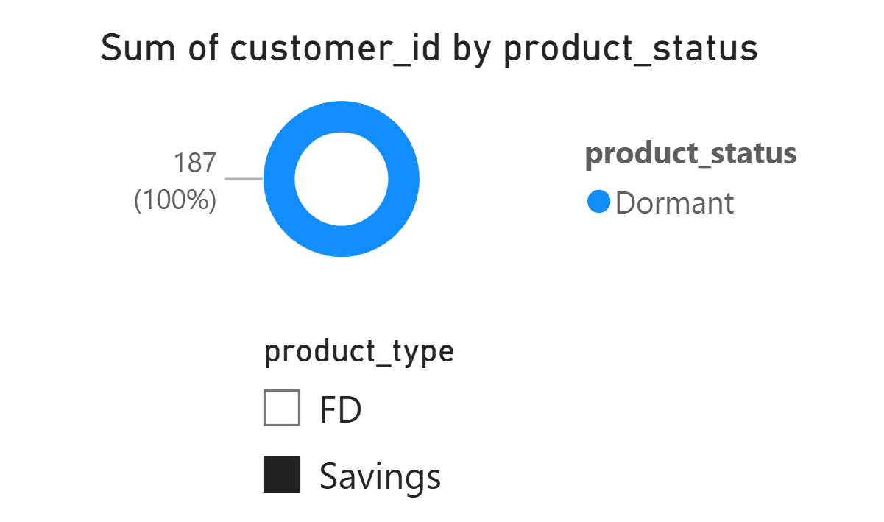

Explanation:

All 187 customers shown have dormant savings accounts, presenting an opportunity for the bank to reconnect with these users through SMS/email nudges, incentives, or digital banking upgrades.

* Action: Retarget customers for product reactivation.

7. Channel Usage vs. Cross-Sell Score

Target digital users for online financial products.

* Tables Used: Customer_Service_Usage, Customer_Product, Customers
* Power Query:
  + Filter is_active = TRUE and digital services (NetBanking, MobileApp)
* Visual: Bar Chart
  + X: Service Type
  + Y: Average Product Count
  + Slicer: Age

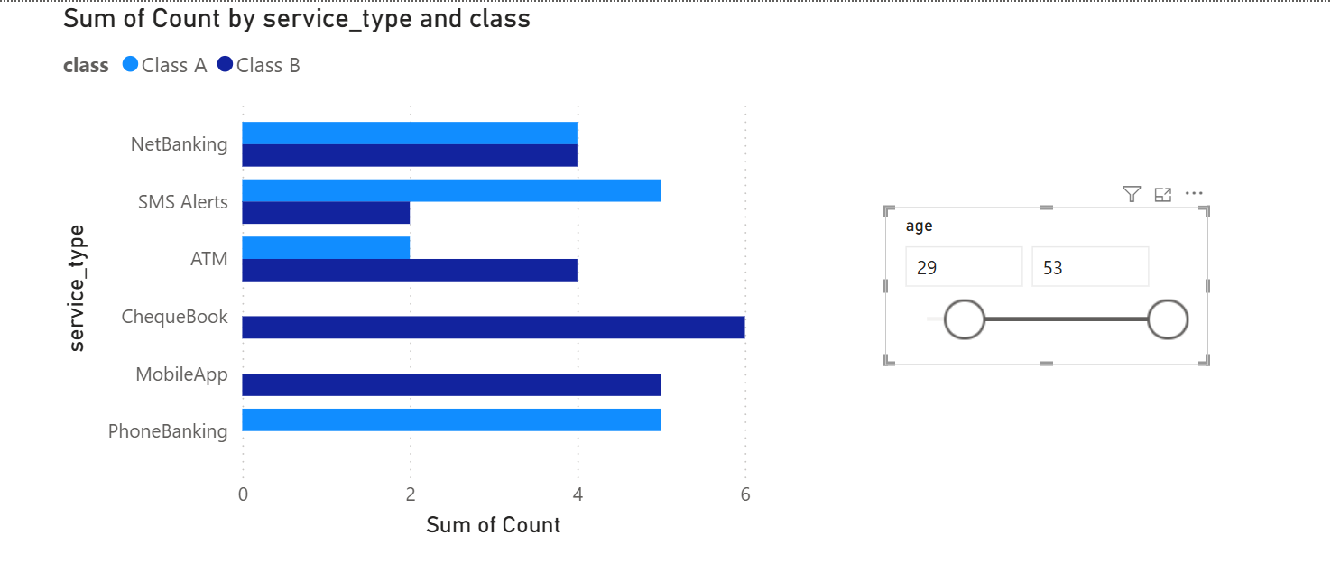

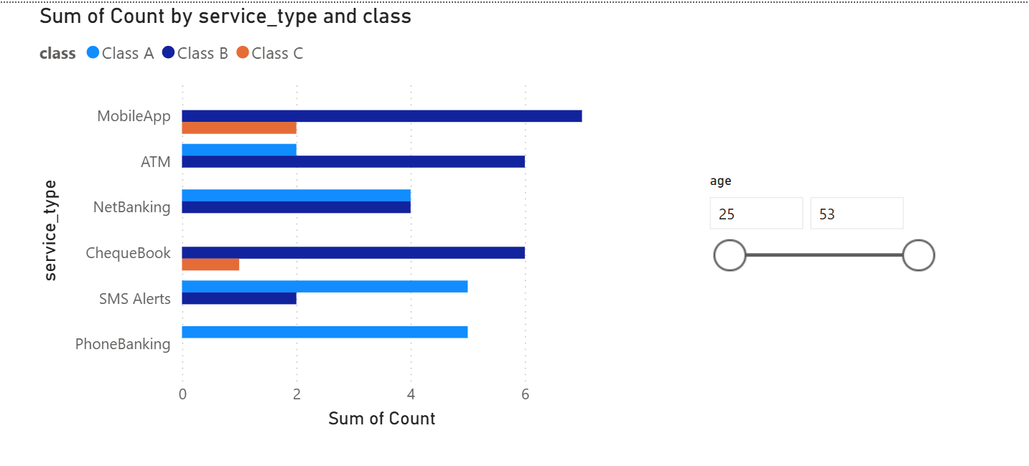

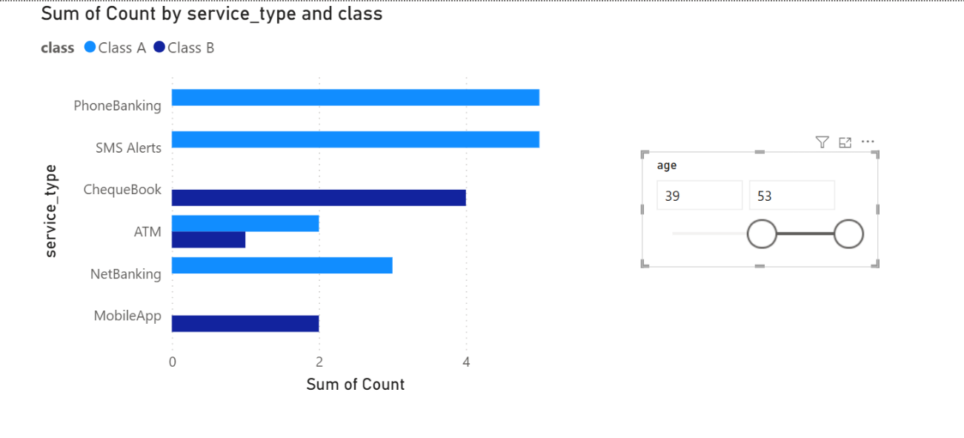

Explanation:  
Filtered by age, this visual confirms that NetBanking and MobileApp are highly used, followed by Chequebook. It supports the idea of age-personalized digital campaigns.

This version shows an older age range (39–53). Despite age, Phone and SMS banking are popular. Promoting hybrid channels (phone + app) may better engage older digital users.

* Action: Promote SIPs, online FDs to digital-savvy but under-utilizing customers.

Key Insights

* Product Penetration: High-value customers hold fewer FDs and Loans than expected—strong potential for targeted outreach.
* Branch Performance: Pune branches show high product engagement (Avg = 10), while Jalgaon is underperforming (Avg = 0).
* Insurance Gap: 23.3% of loan customers are uninsured—key opportunity for insurance upselling.
* Dormant Analysis: 187 dormant customers—ideal for reactivation offers.
* Channel Preference: NetBanking & MobileApp users dominate—potential to promote digital products over ATM-based ones.
* Skills Applied
* MySQL Database Design and Querying
* Power Query Data Transformation
* DAX for Business Calculations
* Power BI Dashboard Design
* Customer Segmentation and Behavioral Analytics
* Business Recommendations for Cross-Selling

**Final Conclusion**

This cross-selling study identifies **high-potential customers, underutilized branches, insurance gaps, and dormant product opportunities**, which can be directly used to personalize marketing efforts and increase product adoption across the bank’s ecosystem. Here's a breakdown of the key takeaways:

**🔹 1. Customer Segmentation & Product Penetration**

* **Finding**: High-value customers (income > ₹8L) show **low FD and loan product usage**.
* **Impact**: These customers have high financial capacity but underuse core banking products.
* **Recommendation**: **Target with premium investment and loan offerings** (e.g., wealth management, home loans).

**🔹 2. Life Event Triggers**

* **Finding**: Married customers without health insurance and those visiting for loan/account purposes present **prime opportunities for cross-sell**.
* **Impact**: Timely, context-based marketing during major life events increases conversion.
* **Recommendation**: Automate **Life Event Campaigns** with tailored products (health insurance, joint accounts, etc.).

**🔹 3. Loan Eligibility Dashboard**

* **Finding**: Customers with high balances and transactions but no current loans are **potential loan candidates**.
* **Impact**: Missed revenue from untapped loan prospects.
* **Recommendation**: Run **loan pre-approval and offer campaigns** based on eligibility score.

**🔹 4. Insurance Gap Funnel**

* **Finding**: 23.3% of loan holders lack insurance coverage.
* **Impact**: Risk exposure for both bank and customer.
* **Recommendation**: Upsell **credit life or personal accident insurance** with loan renewals.

**🔹 5. Branch-Level Cross-Sell Performance**

* **Finding:** Jalgaon has the highest number of branches, showing strong potential for cross-selling. Pune also performs well, while other cities have limited presence**.**
* **Impact:** Jalgaon offers a key opportunity to boost product penetration; smaller cities may need digital outreach.
* **Recommendation:** Focus cross-sell campaigns and staff incentives in Jalgaon. Use digital channels to engage customers in cities with fewer branches.

**🔹 6. Dormant Product Reactivation**

* **Finding**: 187 customers have dormant products.
* **Impact**: Unutilized revenue and engagement opportunities.
* **Recommendation**: Launch **re-engagement offers**, such as bonus interest for reactivating FDs.

**🔹 7. Digital Channel Utilization**

* **Finding**: NetBanking and MobileApp users dominate, but their product usage is suboptimal.
* **Impact**: Digital-savvy customers are ready for **cost-effective product delivery**.
* **Recommendation**: Promote **online FDs, SIPs, and e-Insurance** via app and net banking.

**How This Will Help the Bank**

1. **Revenue Growth**: Cross-selling Loans and Insurance to High-Value customers and reactivating dormant accounts will increase revenue per customer. Bundled offers from affinity analysis can further boost product uptake.
2. **Targeted Campaigns**: The Insurance Gap Funnel provides a list of 7 uninsured loan customers, and the Branch Cross-Sell Heatmap (corrected to a map) identifies low-penetration cities (e.g., Jalgaon) for focused marketing, improving conversion rates.
3. **Enhanced Engagement**: Re-engaging 187 dormant customers with tailored offers strengthens retention, while digital channel focus aligns with customer behavior, enhancing interaction.
4. **Operational Efficiency**: Prioritizing digital promotions reduces branch workload, and the map-based heatmap optimizes resource allocation to underperforming regions.
5. **Risk and Growth Balance**: Closing the insurance gap mitigates risk for loan customers, while expanding loan and digital product portfolios drives sustainable growth.

**Strategic Next Steps**

1. **Automate Campaigns** based on life events, eligibility, and dormant triggers.
2. **Equip Branches** with insights on low-performing cities for localized campaigns.
3. **Implement Dashboards** for real-time tracking of cross-sell KPIs.
4. **Use Digital Channels** to run targeted product pushes where usage is already high.